NOTICE OF MEETING OF THE

COMMISSIONERS COURT OF FRIO COUNTY, TEXAS

Notice is hereby given that a Regular Called Meeting of the above-named Commissioners Court will be held on the **11th**day of **October, 2022**, at **3:00 p.m**., in the Frio County Courtroom, Pearsall, Texas, and also via video conference with a link provided at <http://www.co.frio.tx.us/>. It is the intent of the Frio County Commissioners Court that a quorum of the court and the presiding member of the court will be present at the above-mentioned location and time. Court members may be participating via videoconference pursuant to Tex. Gov’t Code § 551.127. Interested citizens may participate in person at the courthouse, but due to the COVID-19 pandemic, citizens are encouraged to instead participate by accessing the weblink found on the above-mentioned address. During the meeting, the following subjects will be discussed, to-wit:

I. Invocation and Pledge of Allegiance

II. Adopt Agenda

**Move Agenda Item #22 to #16**

**Motion by: Commissioner Carrizales**

**Seconded by: Commissioner Asuncion**

**Motion Carried**

III. Old Business

**None**

**PRESENTATION**

**ACTION AGENDA ITEMS**

IV. General Discussion

V. Citizens To Be Heard

*Please note that the Rules of Procedure, Conduct and Decorum at Meetings of the Commissioners Court of Frio County, Texas limit each speaker to a maximum of three (3) minutes to make his or her remarks. Inappropriate conduct or comments during this time, including but not limited to disruptive behavior, insults, personal attacks, and inappropriate language, may result in the speaker being ordered to leave the meeting and forfeit any remaining speaking time. For more information regarding the above-mentioned rules, please see the complete Rules of Procedure, Conduct and Decorum at Meetings of the Commissioners Court of Frio County, Texas, which is available upon request.*

VI. New Business

**PRESENTATION**

(1) Ronald Rocha, Attorney at Law, Linebarger Goggan Blair & Sampson, LLP**,** requests:

Update on the delinquent fines and collection services by Linebarger Goggan Blair & Sampson LLP.

**Not able to attend**

(2) Jerica Jensen, Senior Account Executive, Textmygov.com, requests:

Presentation regarding the services offered by TextMyGov.

**Not Present**

**ACTION AGENDA ITEMS**

(1) Yolanda Rendon, requests:

Consider/take action on approving the county to pay Trevino Royal Oaks Funeral Chapels for the indigent cremation for Juan and Aurora Rendon.

**Motion by: Judge Luna**

**Seconded by: Commissioner Carrizales**

**Motion Carried**

(2) Carlos Segura, Frio County Elections Administrator, requests:

Discuss and approve the change in Election Day Voting Box Locations for the November 8, 2022.  This specifically includes changing the regular voting Box #3, (Pearsall Public Library) to new site of Box #1, (Frio County Conference Room), due to the library temporarily housing/storing confidential materials causing the site to be unavailable.

**No Action**

(3) Hon. Arnulfo C. Luna, Frio County Judge, requests:

Consider/take action on entering into a Donation Agreement between Frio County and Union Pacific Railroad Company for acceptance by Frio County of two (2) signal cabins from Union Pacific Railroad Company for use by Frio County.

**Motion by: Commissioner Carrizales**

**Seconded by: Commissioner Asuncion**

**Motion Carried**

(4) Hon. Arnulfo C. Luna, Frio County Judge, requests:

4.1 Consider/take action on accepting the resignation of Sara Pichardo as the Frio County Information Officer.

4.2 Discussion regarding the filling of that position going forward

**No Action**

(5) Hon. Jose Asuncion, Frio County Commissioner, Precinct No. 4, requests:

Consider/take action on allowing South Texas Rural Health Services to use Office 109 in the Dilley Annex building to provide Frio County residents with application assistance.

**Motion by: Commissioner Asuncion**

**Seconded by: Commissioner Carrizales**

**Motion Carried**

(6) Hon. Jose Asuncion, Frio County Commissioner, Precinct No. 4, requests:

Discuss/take action on adjusting comp time guidelines in the 2022 Employee handbook.

**No Action**

(7) Hon. Mike Morse, Frio County Sheriff, requests:

Discuss and consider implementation of Land Owner Damaged Property subsidy policy.

**Discussion, does not need vote**

(8) Hon. Mike Morse, Frio County Sheriff, requests:

Discuss and consider utilizing funding set aside for a School Resource Officer position that was not approved by Dilley ISD, to create an additional 911 Dispatcher position.

**No Action**

(9) Hon. Mike Morse, Frio County Sheriff, requests:

Consider/take action on waiving the probationary period for being able to access Blue Cross Blue Shield of Texas Insurance Benefits for new employees Deputy Sheriff Officers Marcos Reyes and Larissa Leal.

**Motion by: Judge Luna**

**Seconded by: Commissioner Carrizales**

**Motion Carried**

(10) Hon. Mike Morse, Frio County Sheriff, requests:

10.1 Consider/take action on entering into an Intergovernmental Agreement between Frio County and La Salle County for the housing of La Salle County Inmates in the Frio County Jail.

10.2 If the agreement is approved, consider/take action on approving a resolution authorizing Hon. Arnulfo C. Luna, Frio County Judge, to enter into same on behalf of Frio County.

**Motion by: Commissioner Carrizales**

**Seconded by: Commissioner Asuncion**

**Motion Carried**

(11) Hon. Mike Morse, Frio County Sheriff, requests:

11.1 Consider/take action on entering into an agreement with 5 Star Correctional Services, Inc. for inmate food services for the Frio County Jail.

11.2 If the agreement is approved, consider/take action on approving a resolution authorizing Hon. Arnulfo C. Luna, Frio County Judge, to enter into same on behalf of Frio County.

**Motion by: Commissioner Carrizales**

**Seconded by: Commissioner Asuncion**

**Motion Carried**

(12) Hon. Mike Morse, Frio County Sheriff, requests:

12.1 Consider/take action on entering into a One-Time Service Contract with Willo Products Company, Inc. for servicing the doors, door boxes, and door controls for the Frio County Jail.

12.2 If the agreement is approved, consider/take action on approving a resolution authorizing Hon. Arnulfo C. Luna, Frio County Judge, to enter into same on behalf of Frio County.

**Motion by: Commissioner Carrizales**

**Seconded by: Commissioner Asuncion**

**Motion Carried**

(13) Hon. Mike Morse, Frio County Sheriff, requests:

Consider/take acting on signing resolution requesting the addition of the signatories Jail Captain Mace Martinez and Sergeant Esther Leal to the below accounts at Security State Bank that for the Frio County Sheriff’s Department:

Frio County Jail Commissary account #0100069806

**Motion by: Commissioner Carrizales**

**Seconded by: Commissioner Asuncion**

**Motion Carried**

(14) Hon. Mike Morse, Frio County Sheriff, requests:

Consider/take action on approving termination letter to Encartele to terminate phone services contract for inmates housed in the Frio County Jail. Termination to be effective January 5, 2023. Authorize Sheriff Michael Morse to send the letter on behalf of Frio County.

**Omit per Chief**

(15) Hon. Crystal Marquez, Frio County Auditor, requests:

15.1 Consider / take action on approving resolution to authorizing Hon. Arnulfo C. Luna, the Frio County Judge to act as the designated agent to apply for the Texas Indigent Defense Formula Grant Program for the year 2023.

15.2 If the resolution is approved, then authorized Hon. Judge Arnulfo C. Luna to sign the resolution with Texas Indigent Defense Commissioner.

**Motion by: Commissioner Asuncion**

**Seconded by: Commissioner Carrizales**

**Motion Carried**

(16) Hon. Crystal Marquez, Frio County Auditor, requests:

16.1 Consider / take action to approve the budget amendments to the FISCAL YEAR 2022-2023 Frio County Budget, list below:

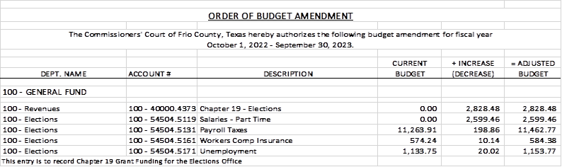

16.2 If the amendment is approved, consider/take action on signing order stating same.

**Motion by: Commissioner Carrizales**

**Seconded by: Commissioner Asuncion**

**Motion Carried**

(17) Hon. Crystal Marquez, Frio County Auditor, requests:

17.1 Consider / take action to approve the budget amendments to the FISCAL YEAR 2022-2023 Frio County Budget, list below:

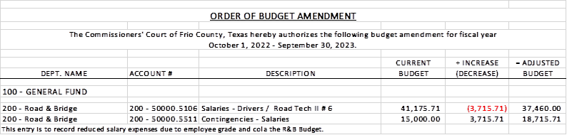

17.2 If the amendment is approved, consider/take action on signing order stating same.

**Motion by: Commissioner Carrizales**

**Seconded by: Commissioner Asuncion**

**Motion Carried**

(18) Hon. Crystal Marquez, Frio County Auditor, requests:

18.1 Consider / take action to approve the budget amendments to the FISCAL YEAR 2022-2023 Frio County Budget, list below:

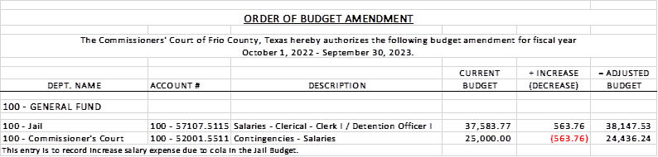

18.2 If the amendment is approved, consider/take action on signing order stating same.

**Motion by: Commissioner Carrizales**

**Seconded by: Commissioner Asuncion**

**Motion Carried**

(19) Hon. Crystal Marquez, Frio County Auditor, requests:

19.1 Consider / take action to approve the budget amendments to the FISCAL YEAR 2022-2023 Frio County Budget, list below:

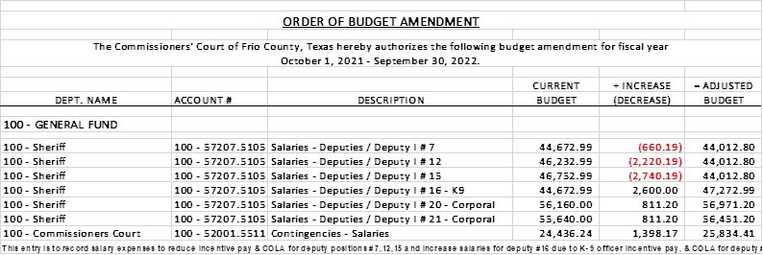

19.2 If the amendment is approved, consider/take action on signing order stating same.

**Motion by: Commissioner Carrizales**

**Seconded by: Commissioner Asuncion**

**Motion Carried**

(20) Hon. Crystal Marquez, Frio County Auditor, requests:

20.1 Consider / take action to approve the budget amendments to the FISCAL YEAR 2022-2023 Frio County Budget, list below:

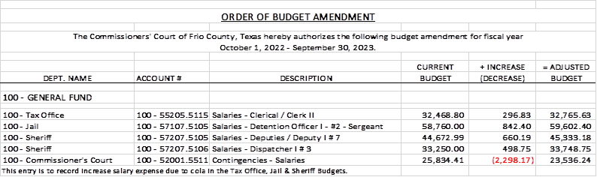

20.2 If the amendment is approved, consider/take action on signing order stating same.

**Table Discussion**

(21) Hon. Crystal Marquez, Frio County Auditor, requests:

Consider / take action on accepting proposal and approval of payment for Frio County Public Officials Liability ($19,078.00) and Law Enforcement Liability Insurance ($31,495.00) coverage for the period of October 01, 2022 to October 1, 2023 for a total of $50,573.00, which is an increase of $6,887.00 from last year.

**Motion by: Commissioner Asuncion**

**Seconded by: Commissioner Carrizales**

**Motion Carried**

(22) Hon. Crystal Marquez, Frio County Auditor, requests:

Discuss / take action to clarify who qualifies for the 1.5% cost of living (COLA) to the 2022-2023 budget.

**Table Discussion**

(23) Roxana Garcia, P.E., Frio County Engineer, requests:

Consider/take action on selecting the low bidder for the Bridge and Approach Replacement Project for bridges located on CR 2410/ San Miguel Rd. and CR 3314/ E. Goldfinch Rd. in Frio County, Texas.

**Motion by: Commissioner Carrizales**

**Seconded by: Commissioner Asuncion**

**Motion Carried**

(24) Roxana Garcia, P.E., Frio County Engineer, requests:

Consider / take action on running a sealed request for qualifications (RFQ) ad (below) in the Frio Nueces Current once a week for two weeks pursuant to Local Government Code Sec. 262.025.  The ad will run in the Frio-Nueces Current on October 13, 2022, October 20, 2022, October 27, 2022, November 3, 2022 and ending on November 10, 2022.  Sealed RFQ’s will be accepted in the Auditor’s office until 3:00 pm, November 10, 2022.  RFP’s will be opened during commissioner’s court on 15, 2022.

**Motion by: Commissioner Carrizales**

**Seconded by: Commissioner Asuncion**

**Motion Carried**

**REQUEST FOR QUALIFICATIONS**

By order of the Commissioner’s Court of Frio County, Texas, and pursuant to Section 262.023 of the Texas Local Government Code, the County is accepting qualifications for an engineering firm registered in the State of Texas to assist the County with Construction Engineering Inspection (CEI) services. Qualifications will be received at the Frio County Auditor’s Office located at 500 E. San Antonio Street, Pearsall, Texas 78061 until **3:00 P.M., November 10, 2022**. Qualifications received after the time indicated will be returned unopened. Prospective firms may contact Roxana Garcia, P.E. at 2207 BL 35 E, Pearsall, Texas 78061; phone 830-334-0085; or by e-mail at [Roxana.Garcia@friocounty.org](mailto:Roxana.Garcia@friocounty.org) in regards to obtaining the RFQ documents. An appointment to discuss the RFQ may be scheduled by contacting Ms. Garcia. Frio County reserves the right to reject any and all RFQs. Frio County is an Affirmative Action/Equal Opportunity Employer. For more information, visit <http://www.co.frio.tx.us/>.

(25) Roxana Garcia, P.E., Frio County Engineer, requests:

Discussion regarding the need for information technology services for Frio County.

**No Action**

(26) Roxana Garcia, P.E., Frio County Engineer, requests:

Consider/take action on approving a job vacancy reclassification from Administrative Assistant to Executive Administrative Assistant in the Road and Bridge Department.

**No Action**

(27) Roxana Garcia, P.E., Frio County Engineer, requests:

Discussion regarding the progress of the Frio County Building Improvement Project located at 1796 IH 35E, Pearsall, Texas 78061.

(28) Hon. Aaron Ibarra, Frio County Clerk, requests:

28.1 Consider/take action on entering into a Book Scanning and Indexing Service Agreement with Scott-Merriman, Inc. for scanning and indexing of records located in the Frio County Clerk’s Office.

28.2 If the agreement is approved, consider/take action on approving a resolution authorizing Hon. Arnulfo C. Luna, Frio County Judge, to enter into same on behalf of Frio County.

**Motion by: Commissioner Carrizales**

**Seconded by: Commissioner Asuncion**

**Motion Carried**

(28) Frio County Commissioners Court, requests:

Receive in person from the following county officials the following reports as mandated by law:

28.1 Presentation by Frio County Treasurer of detailed report as mandated by Section 114.026, Local Government (“Code”) (this report is to be presented at each **regular term of commissioners court).**

28.2 Frio County Treasurer to exhibit the books and accounts of that office for the inspection of the commissioners court (**to be done at each regular term of commissioners court).**

28.3 Consider/take action on authorizing the execution by Frio County Commissioners Court (the Judge and each commissioner) of an affidavit stating the requirements of the treasurer’s report have been met as mandated by section 114.026 of the Code.

28.4 Consider/take action on execution of an order of the commissioners court approving the county treasurer’s report and order their publication in the Frio-Nueces Current as mandated by Section 114.026 of the Code or publication on the county’s website.

**Motion by: Commissioner Carrizales**

**Seconded by: Commissioner Asuncion**

**Motion Carried**

(29) Frio County Commissioners Court requests:

Presentation, pursuant to Section 114.044 of the Local Government Code, by:

1. Frio County District Clerk;

2. Frio County Clerk

3. Frio County Treasurer

4. Frio County Attorney

5. Frio County Judge

6. Frio County Sheriff

7. Frio County Auditor

8. Frio County Justice of the Peace

9. Frio County Constables

**(who collects or handles any money for the use of the county) of all fines imposed, judgments rendered and collected, and all jury fees collected by the respected courts in favor of or for the use of the county and at that time when the reports are presented to present receipts vouchers that show disposition of the money, fines or judgments.**

After examination by the commissioners court as to the correctness of the reports, consider/action on directing the county clerk to enter information in county finance records as mandated by Section 114.044 of the Code.

**JP 4 and Constable 1 did not submit reports**

**Motion by: Commissioner Carrizales**

**Seconded by: Commissioner Asuncion**

**Motion Carried**

(30) Documents (resolutions, orders, contracts, etc.) to be signed.

**Reviewed and signed**

(31) Allow bills payable

**Motion by: Commissioner Carrizales**

**Seconded by: Commissioner Asuncion**

**Motion Carried**

(32) Adjourn

**Motion by: Commissioner Carrizales**

**Seconded by: Judge Luna**

**Motion Carried**

**THE FRIO COUNTY COURTHOUSE IS WHEELCHAIR ACCESSIBLE AND HANDICAP PARKING IS AVAILABLE. ANY REQUEST FOR SIGN INTERPRETIVE SERVICES MUST BE MADE 48 HOURS PRIOR TO THE MEETING. TO MAKE ARRANGEMENTS, PLEASE CALL (830) 334-2154.**

**THE FRIO COUNTY COMMISSIONERS COURT RESERVES THE RIGHT TO CONVENE INTO CLOSED (EXECUTIVE SESSION) UNDER V.T.C.A., GOVERNMENT CODE, CHAPTER 551, SUBCHAPTER D; SECTION 551.071, FOR PURPOSE OF CONSULTING WITH ITS ATTORNEYS; SECTION 551.072, DELIBERATING ABOUT REAL PROPERTY; SECTION 551.073, DELIBERATING ABOUT GIFTS, AND DONATIONS; SECTION 551.074, DELIBERATING ABOUT PERSONNEL MATTERS; SECTION 551.076, DELIBERATING ABOUT SECURITY DEVICES; SECTION 551.084, REGARDING EXCLUSION OF WITNESS FROM HEARING IN CONNECTION WITH AN INVESTIGATION; SECTION 551.086, DELIBERATING, VOTING, AND TAKING ACTION AS A POWER UTILITY ON A COMPETITIVE MATTER; SECTION 551.087, DELIBERATING ABOUT ECONOMIC DEVELOPMENT NEGOTIATIONS; AND SECTION 551.088, DELIBERATING ABOUT TEST ITEMS TO DISCUSS AND/OR DELIBERATE ANY OF THE POSTED MATTERS TO BE CONSIDERED DURING THE OPEN MEETING AND, IF IT DOES SO AFTER TAKING A VOTE IN OPEN SESSION, IT WILL THEN GO INTO CLOSED (EXECUTIVE) SESSION, DELIBERATE, THEN RECONVENE IN OPEN SESSION, VOTE ON ANY DECISION TAKEN, AND ANNOUNCE SAME FOR THE COMMISSIONERS COURT’S MINUTES.**

Dated this the 7th of October, 2022.

_________________________________________

Hon. Arnulfo C. Luna

Frio County Judge

I, the undersigned, County Clerk, do hereby certify that the above Notice of Meeting of the above-named Commissioners’ Court, is a true and correct copy of said Notice on the bulletin board at the Courthouse door of Frio County, Texas at a place readily accessible to the general public at all times on the **7th** day of **October,** **2022** and said Notice remained so posted continuously for at least 72 hours preceding the scheduled time of said Meeting.

Dated this the 7th day of October, 2022.

COUNTY CLERK, FRIO COUNTY, TEXAS

BY____________________________________